Assessment Schedule – 2013

Physics: Demonstrate understanding of mechanics (91171)

Evidence Statement
 | Achievement |  | Merit |  | Excellence
ONE  (a) | 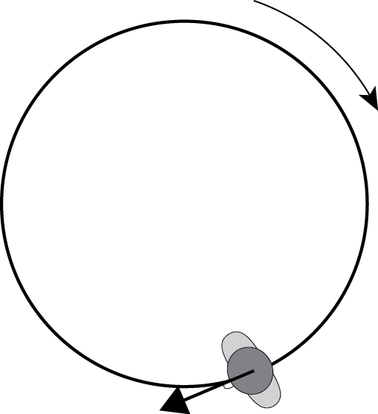
(b) | 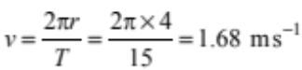  OR  Used incorrect value of “v” to calculate F_{c} |  | 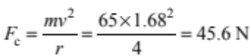  = 46 N  **Use R for rounding error
(c) | 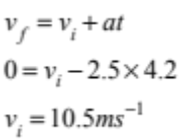 |  | Added (44.1 +22.05)to get incorrect answer of 66.15 m  *circle + sign  OR  Assumed v_{i} =0 and worked out answer. |  | 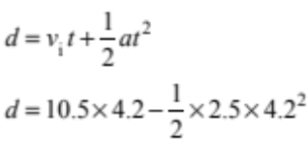  d = 44.1 – 22.05  d = 22.05 m  OR  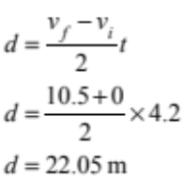
(d) | ONE OF:  - Net force = 0.  - Reaction force acts at 90° to surface.  - Friction acts upwards along surface.  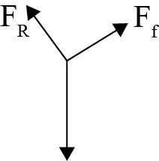  - Closed triangle to show balanced forces with correct labels  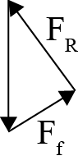 |  | TWO OF:  - Net force = 0.  - Reaction force acts at 90° to surface AND Friction acts upwards along surface.  (** No contradictory vectors)  - Closed triangle to show balanced forces with correct labels |  | ALL OF:  - Net force = 0.  - Reaction force acts at 90° to surface AND Friction acts upwards along surface.  - Closed triangle to show balanced forces with correct labels. Or shows that sum of horizontal and vertical components add to zero.
TWO  (a) | 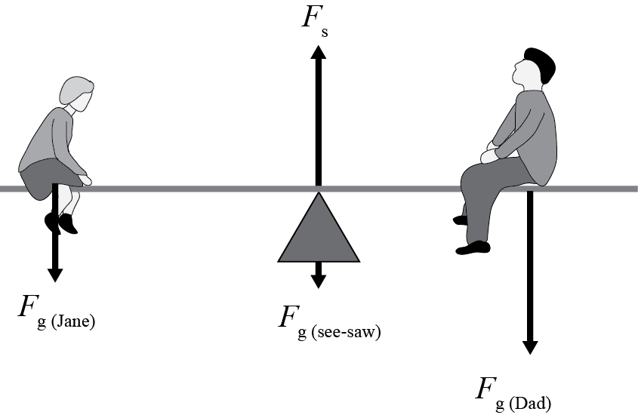  All four vectors correct without labels.  OR three correct vectors labelled. | All four vectors correctly drawn and labelled. F_{s} must be larger.
(b) | 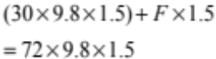  441 × F × 1.5 = 1058  OR  (450 +F × 1.5 =1080)  OR  294 +F_{s} = 705.6  OR  Taking moments / calculating torques wrt to Dad’s end:  (30 × 9.8 × 3.0) + (60 × 9.8 × 1.5) – (F_{S} × 1.5) = 0  where F_{S} is the support force at the pivot when Dad’s end is on the ground  882 + 882 = 1.5 F_{S} hence F_{S} = 1764 ÷ 1.5 = 1176 N | 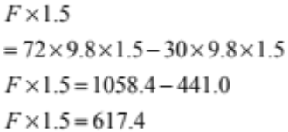  OR (F × 1.5 = 630)  OR  Total F_{UP} = total F_{DOWN}  F_{S} + F_{GROUND}  = (30 × 9.8) + (60 × 9.8) + (72 × 9.8)  = 294 + 588 + 706  = 1588 N |  | 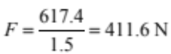  OR  (F = 420 N)  OR  Hence F_{GROUND} = 1588 – 1176 = 412 N
(c) | TWO of:  - The only unbalanced force acting on the ball is the force of gravity.  - Gravity acts downwards.  - This unbalanced force causes the ball to decelerate or accelerate downwards.  - Velocity at the top is zero. | The only unbalanced force acting on the ball is gravity, which acts downwards.  This causes the ball to decelerate or accelerate downwards.  Hence the ball slows down to a stop when it reached maximum height.
(d) | v_{horizontal} = 6.5 cos60 = 3.25 m s^{–1}  OR  v_{vertical} = 5.63 m s^{–1}  **Watch out for values being swapped around. | v_{horizontal} = 6.5 cos60 = 3.25 m s^{–1}  AND  v_{vertical} = 5.63 m s^{–1}  AND  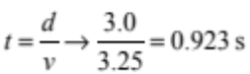  OR  Time to reach max height = 0.57s, so max height =1.6m, so will go only 1.85 m across and so will not go through hoop. |  | 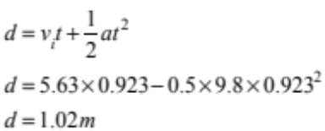  This is less than 1.35 m hence ball will not go through hoop.  OR  Vertical velocity at 1.35 m height  v = 2.29 ms-1  Time taken for v_{f} to reach 2.29ms⁻¹  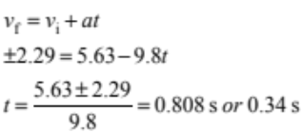  Horizontal distance travelled in 0.808s or 0.34 s  or 1.12 m  This is less than 3.00 m, so ball will not go through the hoop.
THREE  (a) | p = mv  p = 305 × 2.4 =732 kg m s^{–1}  p = 730 kg m s^{–1}  OR  Accept both done separately  (576 kgms^{–1} and 156 kgms^{–1})
(b) | ONE OF:  - Rubber bumpers reduce the force.  - By increasing the time of impact.  - Since change in momentum is the same.  OR  - Rubber bumpers move a distance when compressed,  - so for the same amount of work done or energy changed, or the same change in velocity, acceleration is decreased due to longer time  - less force is used. | TWO OF:  - Rubber bumpers reduce the force.  - By increasing the time of impact.  - Since change in momentum is the same.  OR  - Rubber bumpers move a distance when compressed,  - so for the same amount of work done or energy changed, or the same change in velocity, acceleration is decreased due to longer time  - less force is used. |  | Rubber bumpers reduce the force.  The rubber compresses to increase the time of impact.  Since change in momentum is the same.  OR  - Rubber bumpers move a distance when compressed,  - so for the same amount of work done or energy changed, or the same change in velocity, acceleration is decreased due to longer time  - less force is used.
(c) | Momentum is conserved  (240 + 65) 2.4 → +(240 + 58)2.7 ← = (480 + 65 + 58)v  732→ +804.6← =603v  OR  Solved without adding mass of cart  156 – 156.6 = 0.6  OR  Gets 2.5 ms⁻¹ by adding | 732 → +804.6 ← = 603v  72.6← = 603v  OR  Found velocity without taking mass of cart into consideration  (v =4.9 x10⁻³ ms⁻¹) |  | v = 72.6 / 603 = 0.12 m s^{–1} ←
(d)(i) | 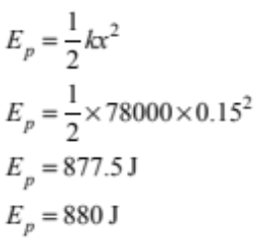

(ii) | 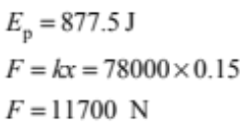  OR average force = 5850 N  OR  9360 with no units | 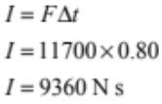  OR  I = 4680 N s  OR  I = 1463 kgms^{–1}

For each question:
N0 | N1 | N2 | A3 | A4 | M5 | M6 | E7 | E8
No evidence | 1a | 2a | 3a | 4a | 3a+1m | 2a + 2m | 2m + 1e | 1m+2e
**Other combinations are possible, but to get M5 or M6 at least one merit question should be correct. To get E7 or E8 at least one excellence question should be correct.

Judgement Statement
 | Not Achieved | Achievement | Achievement  with Merit | Achievement  with Excellence
Score range | 0 – 7 | 8 – 14 | 15 – 19 | 20 – 24

